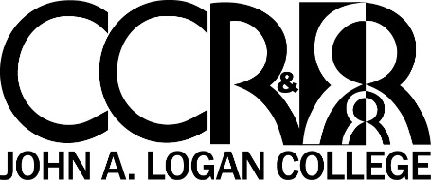
This resource has been created to support center-based programs in meeting the DCFS director and on-site staffing requirements.
700 Logan College Drive
Carterville, IL. 62918
618-985-5975
1-800-548-5563

Looking for college credit related to your work?

Need Gateways credential credit?
Whether you need 3 hours of college credit or a Gateways credential, the resources in this flyer will help you navigate your way to success. There are several options to meet your needs. This resource lists information about community college contacts, training options that give college and credential credits, financial supports and more.

Community College Contacts
John A Logan College  Dr. Marilyn Toliver, Professor/Advisor  618-985-2828, Ext. 8468  marilyntoliver@jalc.edu | Rend Lake College  Heather Miller  618.437.5321, Ext. 1369  millerh@rlc.edu
Kaskaskia College  Alexis Myers  618-545-3351  amyers@kaskaskia.edu | Southwestern Illinois College  Carolyn Beal  618-235-2700, Ext. 5593  carolyn.beal@swic.edu

Each of these colleges offer online options as well as on campus courses. If you are interested in pursuing an early childhood degree we encourage you to contact any college that fits your needs.
Call Child Care Resource and Referral at John A Logan College if you need contact information for colleges not listed on this flyer.

Child Care Resource and Referral  CCR&R offers several trainings that give college credit as well as Gateways credential credit. Be sure to read the course descriptions in our printed newsletter or contact CCR&R to learn more. Every year we offer training that will help you build college credit and credential points while building skills to help you on the job.  McCormick Center for Early Childhood Leadership  MCECL offers online and face-to-face options that give college credit and Gateways credential credit. These options are geared to program administrators and are directly related to the work you do every day. Go to http://cecl.nl.edu/ to find an option that meets your needs. | Financial Support  The Gateways to Opportunities Scholarship Program offers scholarships to early childhood providers. If you work in a licensed child care center or licensed family/group home, the Gateways to Opportunity Scholarship Program may help pay for you to go to college. You can find eligibility information and an application for the Gateways Scholarship Program by visiting www.ilgateways.com or call 1.866.697.8278.    - 7.5-hour training = ½ point credential credit  - Some courses have pre-requisites however an Instructor may be willing to give you a waiver based on past coursework and/or experience.    - Some training options may give you  both college credit and credential credit  - A management/administration course can help meet more than one DCFS requirement  - If you need more than 3 hours of  college credit, pick two courses that only  run for part of the semester.
  FOR MORE GUIDANCE CALL 1-800-548-5563
  ASK FOR Nina, Ashleigh or Chrissy!

